**Chapter-4 (Practice Questions Lecture-13 and 14 )**

1. Use a Karnaugh map to find the minimum SOP form for each expression:



1. Use a Karnaugh map to simplify each expression to a minimum SOP form:



1. Use a Karnaugh map to simplify each expression to a minimum SOP form:

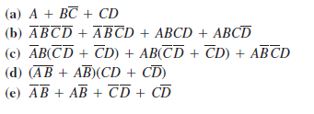

1. Use a Karnaugh map to simplify each Boolean functions.

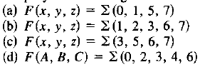

1. Use a Karnaugh map to simplify each Boolean functions.

